Video 24 — Short-Term Memory in LangGraph
CampusX Agentic AI using LangGraph · Playlist position 24 · Theory-first study notes
Watch the lesson · Full playlist
Study scope: Important conceptual material and small teaching examples, not a recreation of the tutorial project. These are original explanatory notes based on the video’s public chapter outline and the linked technical sources—not a transcript.
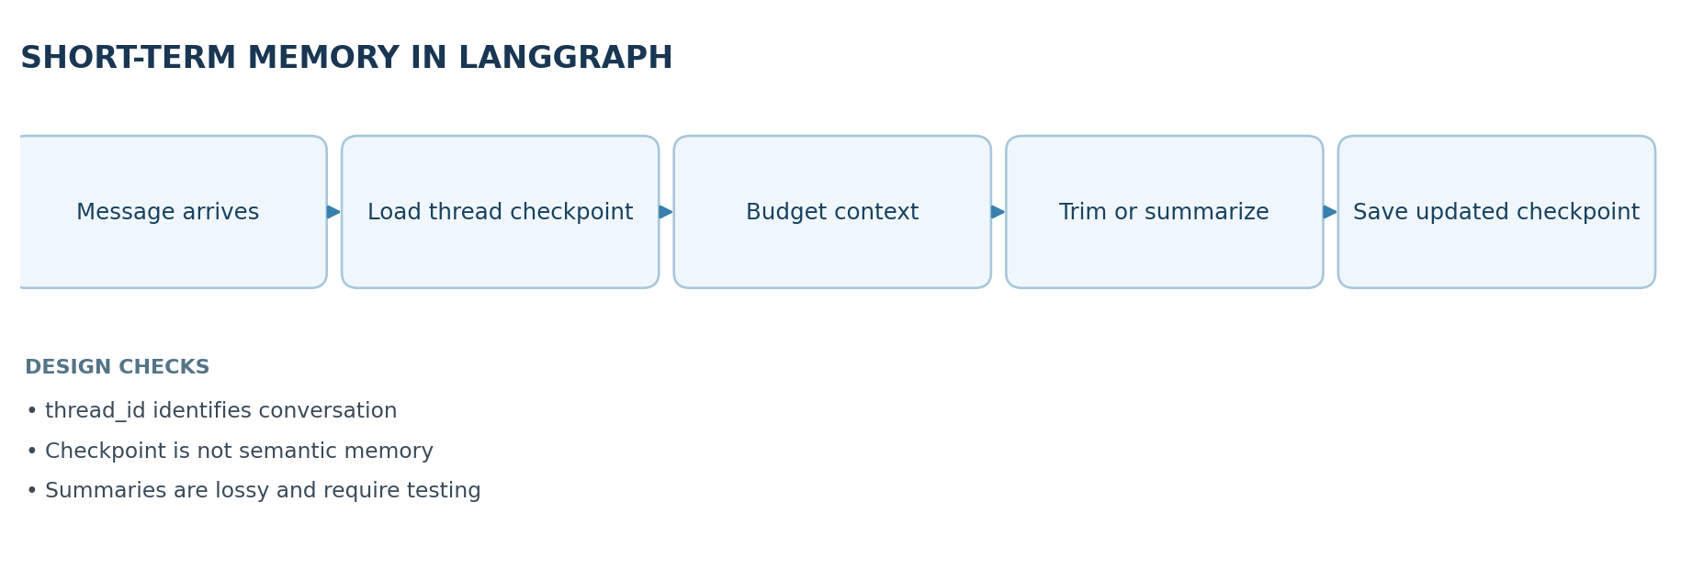

Learning objectives
Explain LangGraph checkpointers, why thread identifiers matter, how PostgreSQL changes persistence durability, and how to manage long conversation histories using trimming, deletion and summarization.

1. What LangGraph short-term memory stores
Short-term memory is the context an agent carries across messages within the same conversation thread. LangGraph represents the workflow's current state as typed fields, often including messages. A checkpointer stores successive snapshots of that state, so the next invocation can load an earlier checkpoint associated with a thread_id.
- thread_id: a stable identifier for one conversation or task. It is not by itself authentication.
- Checkpointer: storage adapter that writes and retrieves graph state and execution progress.
- Checkpoint: saved state at a particular execution step.
- Persistent database: ensures saved state remains available after a process restart (subject to configuration).
Important distinction: saving chat history is not the same as remembering a user's preferences across unrelated threads. For that, use a cross-thread long-term store or a deliberate retrieval mechanism.

2. In-memory vs durable persistence
Storage choice | Strength | Limitation | Typical role
InMemorySaver() | Easy and fast for demonstration | Lost on process exit; not shared across workers | Notebook tests
SQLite-based checkpointer | Durable local file | Local concurrency and operational limits | Prototypes / single-host apps
PostgreSQL checkpointer | Durable, service-friendly relational backend | Database setup, migrations, access and maintenance | Production deployment
Persistence test: send message A in thread X; restart the application; send message B in thread X. If B can use A's history after the restart, the checkpoint store is persistent. Repeat using thread Y to ensure isolation between conversations.

3. Minimal checkpointer pattern
from typing_extensions import TypedDict
from langgraph.graph import StateGraph, START, END
from langgraph.checkpoint.memory import InMemorySaver
class ChatState(TypedDict):
last_message: str
reply: str
def respond(state: ChatState):
return {"reply": f"Received: {state['last_message']}"}
builder = StateGraph(ChatState)
builder.add_node("respond", respond)
builder.add_edge(START, "respond")
builder.add_edge("respond", END)
app = builder.compile(checkpointer=InMemorySaver())
config = {"configurable": {"thread_id": "conversation-001"}}
app.invoke({"last_message": "Hello", "reply": ""}, config=config)
saved = app.get_state(config)
print(saved.values["reply"])
This example shows the mechanism, not a full chat history implementation. Real chat graphs typically use MessagesState and a message reducer to append new turns correctly. Replace the in-memory saver with a durable backend when persistence across restarts is required.

4. Why a context strategy is necessary
A database may store thousands of conversation messages, but a model may only accept a limited number of input tokens. Your application needs to decide which messages to include in the next model call. Keeping the full state in a database does not force the whole history into the prompt. Good systems distinguish the retained historical record from the smaller prompt context.

Strategy comparison
Strategy | What happens | Pros | Risks
Trim | Select a recent/budgeted subset for the model | Simple; bounded tokens | Older dependencies vanish
Delete | Remove selected messages from saved state | Smaller persistent state | History may be permanently lost
Summarize | Replace/complement older history with concise summary | Keeps more context per token | Summary can omit or distort facts
Retrieve | Select relevant earlier turns or external memory | Useful over long periods | Retrieval may miss important facts
Trimming can be prompt-only (preserve history in storage) or state-changing, depending on your code. Deletion is a deliberate mutation of persisted state. Summarization turns multiple turns into an information-dense but imperfect representation.

5. Summarization workflow, step by step
- Count or estimate prompt tokens when a new message arrives.
- If the budget is safe, continue with ordinary recent history.
- Otherwise, summarize older turns, retaining names, decisions, constraints and unresolved questions.
- Keep a recent uncompressed window next to the summary so local references remain accurate.
- If required, delete old messages from state using appropriate message IDs/reducer semantics.
- On the next turn, build the prompt from system instruction + summary + recent turns + new user input.
Example: a user and assistant plan a week-long itinerary over 30 messages. A useful summary preserves the travel dates, cities, budget, and reservations; it does not need every abandoned hotel suggestion.

6. Common implementation mistakes
- Starting every request with a fresh thread_id: continuity disappears.
- Reusing one thread ID for multiple users: data from separate conversations can mix.
- Confusing a stored checkpoint with a valid, concise prompt context.
- Deleting old turns before the summary captures important decisions.
- Trimming away tool call / tool result pairs, causing malformed message sequences.
- Summarizing repeatedly without verification; errors can compound across summaries.
- Assuming InMemorySaver survives a server or notebook restart.

7. Production checkpoints
Use durable storage with backups, sensible retention, encryption and access control. Consider thread ownership checks, database connection handling, and how snapshots are deleted on user request. Where messages contain private data, minimize what is written to logs and traces.

8. Quick revision
Short-term memory is per-thread state backed by a checkpointer. A durable checkpointer addresses restarts; context management addresses token limits. These are independent problems, and a production system generally needs both solutions.

Self-check questions
- Why does changing the thread ID change the accessible conversation state?
- Which problem does PostgreSQL solve that a context summarizer does not?
- How is trimming different from deleting the messages in persisted state?
- What information should survive when summarizing a travel-planning conversation?
Suggested answers: (1) checkpoints are looked up per thread; (2) process-restart durability; (3) one can only filter prompt input, the other removes saved data; (4) decisions, requirements, dates and unresolved tasks.

Visual recap
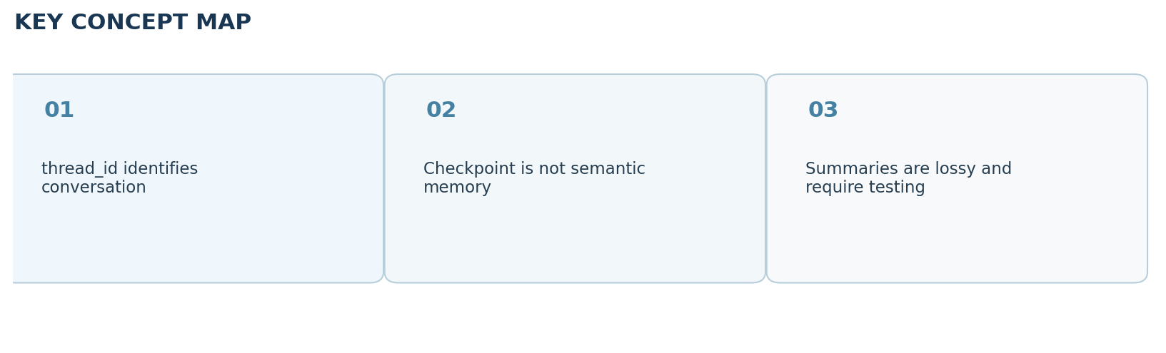

Clickable video chapters
- 00:00:00 — Overview
- 00:01:38 — Stateless LLM recap
- 00:03:33 — Checkpointers and short-term memory
- 00:04:46 — Threads and in-memory state
- 00:09:22 — In-memory limitations
- 00:11:16 — Production persistence
- 00:12:38 — PostgreSQL with Docker
- 00:15:54 — PostgreSQL checkpointer
- 00:17:36 — Restart persistence test
- 00:19:30 — Context overflow
- 00:21:38 — Trimming messages
- 00:31:19 — Trimming trade-offs
- 00:32:03 — Summarization approach
- 00:35:24 — Deleting old messages
- 00:40:12 — Summarization graph
- 00:49:26 — Testing summaries
- 00:52:08 — Recap

References and further reading
- CampusX video and chapters
- LangGraph add-memory guide
Prepared October 2026. Figures are original study diagrams, not screenshots or official CampusX illustrations. Some APIs may change; consult the linked official references before production use.

